Holbrook Surgery Patient Participation Group (PPG)
Holbrook Surgery Newsletter
Autumn |  | September 2023
Come and meet your PPG Committee

We are holding an open evening at the surgery on Wednesday 25th October between 6 and 7pm. This is an opportunity to come and talk to us about the PPG and for us to learn about the issues you think are important. Lisa Ellis, the Practice Manager and hopefully some other members of the surgery team are also going to be present. We are very keen to recruit new members for our committee. If you are interested in joining us this would be a really good opportunity to come and talk to us. We will send an email reminder nearer the time but please put this date in your diary.
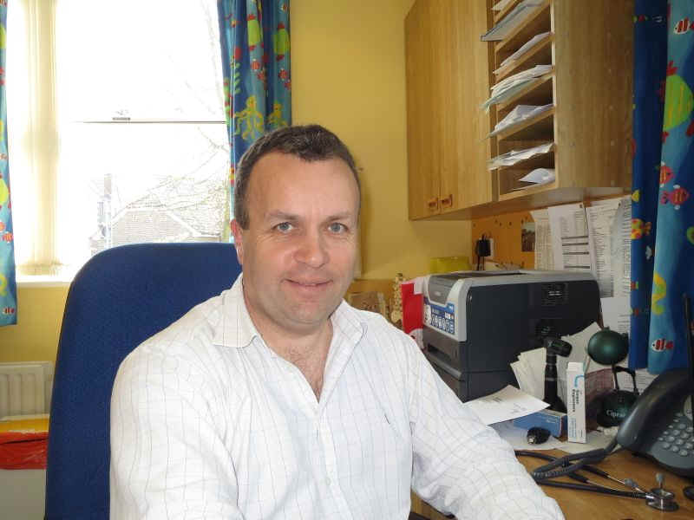
Message from Dr Paul Woods Senior Partner
I am very pleased to have taken over as senior partner from Jon Heatley, but it is a tall order to fill his shoes, since he is much more of a natural leader than I and we will really miss him! However, there is not much of a hierarchy at Holbrook Surgery, and I see myself as part of a leadership team, comprising all of the partners and our excellent managers, Lisa, Mel and Eri. I hope we can continue to maintain high standards and offer a great service for patients, as seems to be the case at this point in time, according to patient feedback.
My other, equally important role is as the GP trainer here. This means that I supervise and teach GP trainees/registrars - qualified doctors that have worked for at least 2 years in the NHS and have then chosen General Practice as their medical specialty. This is a 3-year Vocational Training Scheme comprising various hospital posts and GP posts. I supervise them remotely when they are in hospital and directly when seeing patients here. This is a very satisfying role, seeing the doctors evolve from relatively inexperienced practitioners into fully fledged GPs. It is also a great way to recruit new GPs when they have finished their training - several of our GPs have been trainees here- we have cherry-picked the best ones of course!
I am very grateful to the PPG for all their hard work and look forward to continuing to work alongside them.

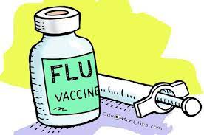
Flu Vaccination Programme
The eligible groups for 2023/24 are as follows:-
- Children aged 2 and 3 years on 31.08.23.
- School aged children [Reception to Year 11]
- 6 months to under 65s in clinical risks groups
- Those in long stay residential care homes
- Carers, those in receipt of the Carer’s Allowance or main carer of an older or disabled person
- Household contacts of immunocompromised individual
- Frontline health and social care staff
This year, the surgery is doing its own vaccinations [except for school aged children which will be done at school]. Flu vaccination clinics are being held at the surgery on Saturdays 7th, 14^{th,} and 28th October. Most eligible patients should have been contacted by SMS or telephone. If you have not heard it is suggested , you contact the surgery.

Autumn 2023 Covid-19 Booster
There is going to be a Covid Autumn Booster. It is not being provided at the same time as the flu jab. The eligible groups are:-
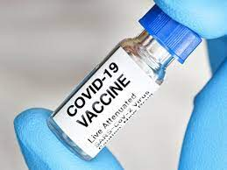
- Residents in care homes for older adults
- All adults aged 65 years and over
- People aged 6 months to 64 years in a clinical risk groups
- Frontline health and social care workers
- People aged 12 to 64 years who are household contacts of people
with immunosuppression
- People aged 16 to 64 years who are carers, and staff working in
care homes
At the time of going to press the arrangements for providing this are not confirmed. We do know that our PCN and the four surgeries which form the PCN are not going to be doing these vaccinations. We understand, however, that the other PCN in Horsham, Horsham Collaborative PCN is going to be doing this which means that our nearest vaccination centre is likely to be Christs Hospital. We are assuming that people will receive an invitation from the NHS in the usual way. We will let you know when we know exactly what is happening.


Back to school - vaccinations reminder
This is the perfect time to make sure your child is up to date with their childhood vaccinations.
Ensuring children have their vaccinations at the right time gives them the best protection and it’s never too late to catch up on missed vaccinations.
Vaccinations are safe, free of charge and available from your GP practice.

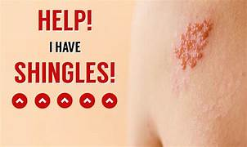
Shingles vaccinations extended.
From September this year almost a million more people will become eligible for a shingles vaccination.
Shingles can be extremely painful, and the pain can remain for many years after the rash has disappeared. It occurs when the Chicken Pox virus, which most of us will have caught in childhood, is ‘reawakened’ – typically in older age, by sickness or by stress.
From 1 September 2023, those turning 65 and 70 will be able to get the vaccine after their birthday, in addition to those already aged 70-80. Only one dose is needed with no requirement for regular boosters.
Eligibility will then be expanded to include those 60 and older by September 2033.
Anyone over 50 who is immunosuppressed will also be offered the vaccination.
If you are over 70 and haven’t already had the shingles vaccination, please give the surgery a call. Younger people will be contacted when they are eligible. For further information
https://www.nhs.uk/conditions/vaccinations/shingles-vaccination/

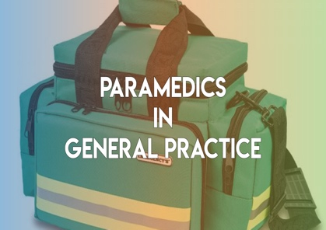
New health care professionals you may see at the Surgery

We have been talking for a long time about how primary care is changing. Although it
may be hard for some to accept, the days of seeing your GP for everything have gone.
and you may now see one of a range of different health care professionals. In previous
newsletters we have given you information about community pharmacists, health
and wellbeing coaches, and social prescribers. Our focus in this newsletter are the paramedics.

Paramedics - People associate paramedics with the Ambulance Service and attending emergencies. Paramedics have however been working in primary care for some years. Some split their time between primary care and continuing to work with the Ambulance Service. Paramedics are highly trained health care professionals who undertake assessments for GPs in order to devise a plan of action or treatment. There are different levels of paramedic reflecting their experience and training. Across the four surgeries which form the Horsham Central Primary Care Network we now have four paramedics working. The paramedics see patients at the surgery, but a lot of their time is spent visiting housebound patients. We have received very positive feedback about the paramedics - importantly that they are able to give more time.

For more information about our paramedics please click on the following link https://www.horshamcentralpcn.co.uk/our-staff and scroll down to Paramedics
Another new health care professional - Pharmacy Technician
The PCN currently has two pharmacy technicians working across the four surgeries. We received this from one of our members:-
‘I picked up my repeat prescription from my nominated Pharmacy and when I got home, I found my post cancer medication was missing. I rang the pharmacy and was advised it was out of stock and they could not tell me when it would be available. Thanks to Holbrook Surgery PPG keeping us patients advised of the Primary Care Network (PCN) and the roles of their staff, I contacted the Pharmacy Technician through the surgery as I know their role is to solve medication stock issues. Mandy the receptionist at Holbrook Surgery took my details and said she would ask the Pharmacy Technician to call me.
Early afternoon I had the call and was told by a very pleasant lady that the medication was at Day Lewis Pharmacy located in Park Surgery and a prescription had been emailed over. I left it to the next day and after a short wait I was given my medication.’

Let us know your experiences of seeing the new health care professionals

Primary Care Network and the four PPGs

The PPGs of the four surgeries which form the Primary Care Network are continuing to meet together to share experience and are also meeting with Dr Sam Khan, the Clinical Director and Ollie Cudd, the Communications Lead. Discussions are still at a very early stage, but we are pleased to report that the PCN seems very keen to involve the PPGs.

Living Well Programme
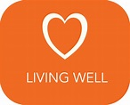
The Living Well programme is a self-management course developed for people who live with long-term health conditions, such as heart disease, asthma, MS, depression, arthritis, ME/CFS, IBS and many more.
The programme aims to help you to take more control of your health by learning new skills to manage your condition better on a daily basis, and to live well.
For more information, pick up a leaflet at the surgery or go online to www.sussexcommunity.nhs.uk/livingwell.


Time to Talk
Talking therapies are run by Sussex Community NHS Foundation Trust who serve the population of West Sussex. They offer a free and confidential service to people age 18 and over who are registered with a local GP. The counsellors and therapists are available at local centres and GP surgeries and can support you over the telephone.
If you are registered with a GP in West Sussex, you can refer yourself directly. You don't have to come via your GP.

For more information pick up a leaflet at the surgery or go online https://www.sussexcommunity.nhs.uk/downloads/services/time_to_talk/timetotalk-crawley-horsham.pdf

Spot Cervical Cancer Early

Whether you've heard about it from a friend or family member, seen it in the news, or are just curious: if you want to know more about spotting cervical cancer early pick up a leaflet at the surgery. You'll find out about possible symptoms, HPV vaccination, screening, and tips for telling your doctor if something is not quite right.
Most cervical cancer cases are in women aged 25-34, but it's also common in older women. If you spot something unusual at any age, tell your doctor. In most cases it won't be cancer - but if it is finding it early can make a real difference
For more information https://www.nhs.uk/conditions/cervical-cancer/symptoms/

FEEDBACK

Hopefully you will have found this newsletter useful. It is always a challenge for us to know how best to pitch this as we realise this is being received by a wide range of people. It would be really useful to know what you found informative, and for that matter what you didn’t. If there are issues which you would like us to address in future newsletters, please let us know.

So, if you have any comments, please let us know on holbrookppg@gmail.com

